Software Requirements Specification (SRS)
Project Title: SereneMind – AI-Powered Therapist

1. Introduction
1.1 Purpose
The purpose of this document is to define and describe the requirements of SereneMind, an AI-powered mental health platform that provides users with personalized therapy, emotional support, and condition monitoring. This SRS will serve as the foundational agreement between the stakeholders—including the development team, project managers, clinical advisors, and end users—on what the system should achieve and how it should behave.
The system aims to fill the gap between traditional therapy sessions and everyday emotional needs by offering a 24/7 conversational therapist, self-help tools, and intelligent monitoring. Additionally, unlike conventional AI therapy applications, SereneMind introduces a doctor escalation mechanism: when a new user first interacts with the AI, an initial backend psychological analysis will automatically assess the severity of the user’s condition. If the system determines potential clinical risks, a detailed assessment report (with user’s consent and contact details) will be forwarded to a licensed psychiatrist or psychologist for professional review. This ensures a safety net where users requiring medication or urgent intervention are not left solely dependent on AI therapy.
This document will guide the full system lifecycle—from design to development, testing, deployment, and maintenance. It will also serve as a reference for compliance, quality assurance, and future enhancements.

1.2 Scope
The SereneMind application is designed as a subscription-based mental health companion, operating on both web and mobile platforms. The primary goal is to democratize access to therapy by providing scalable, affordable, and adaptive AI-driven mental health support.
Core Functions:
Real-time conversational therapy powered by custom-trained AI models.
First-time user analysis to identify possible conditions (e.g., anxiety, depression, stress, PTSD).
Automatic report generation for doctors if medical review is necessary.
Secure database storage with a subscription model (monthly renewable).
Option for users to export their health reports before data deletion if subscription lapses.
Re-import of old reports for continuity in therapy, even when creating a new account.
Personalized therapy programs (journaling, CBT-inspired exercises, relaxation guides).
Regular progress reports and AI-driven suggestions for improvement.
Benefits:
Accessibility: Users have access to a virtual therapist anytime, without geographical or scheduling constraints.
Cost-Effectiveness: Subscription-based pricing makes mental health support more affordable compared to regular clinical visits.
Doctor Safety Net: The doctor escalation ensures that cases requiring medication or urgent attention are properly managed.
System Optimization: Expired accounts are automatically cleared after 5 days of non-renewal, ensuring efficient storage and scalability.
Data Privacy: End-to-end encryption and GDPR-compliant handling of user information.

1.3 Definitions, Acronyms, and Abbreviations
Term | Definition
AI Therapist | The conversational AI system that engages with the user to provide therapy-like interactions.
Escalation Mechanism | The backend process where serious cases are flagged and reported to a human doctor.
Condition Report | A system-generated document summarizing the user’s possible psychological conditions.
Subscription Grace Period | A 5-day period after subscription expiration during which users can renew or export their data.
CBT | Cognitive Behavioral Therapy – a structured, goal-oriented type of psychotherapy.
GDPR | General Data Protection Regulation, compliance standard for data security.
NLP | Natural Language Processing – AI techniques used for understanding human language.

1.4 References
IEEE Std 830-1998 – IEEE Recommended Practice for Software Requirements Specifications.
DSM-5 (Diagnostic and Statistical Manual of Mental Disorders, 5th Edition).
APA Guidelines for Telepsychology Services.
GDPR and HIPAA compliance documents for digital health applications.
Existing AI therapy applications such as Woebot, Wysa, and Replika – analyzed for benchmarking.
Research on AI for psychological assessment (Journal of Medical Internet Research, 2023).

2. Overall Description
2.1 Product Perspective
SereneMind is a hybrid software system that combines AI-driven therapy with human clinical supervision. It is not intended to replace licensed mental health professionals but to augment their work by offering:
Daily, real-time mental health support.
Early detection of serious conditions through AI-based analysis.
Escalation of cases requiring human doctor review.
The product will operate as a cloud-based subscription platform, with access via mobile (Android & iOS) and web applications.
It will integrate the following:
AI Engine – Natural Language Processing (NLP) models trained specifically on therapeutic dialogue.
Doctor Escalation Module – Automatic report forwarding system to healthcare professionals.
User Management & Subscription Module – Handles sign-up, renewals, and data retention.
Analytics & Reporting – Tracks user progress, generates condition assessments, and creates progress charts.

2.2 Product Functions
At a high level, SereneMind will provide the following functions:
Conversational AI Therapy – Users can engage in natural conversations with the AI about their thoughts, feelings, and mental state.
First-Time Analysis – During the initial interaction, the system analyzes user input to identify possible psychological concerns and seriousness of the condition.
Doctor Escalation – If high-risk symptoms are detected, the system generates a report (with user consent) and forwards it to a licensed doctor.
Progress Tracking – Generates weekly and monthly reports for users, with suggested activities and therapy plans.
Subscription & Data Management – Paid monthly subscription with a 5-day grace period; expired accounts are purged unless users export data.
Data Import/Export – Users may export reports for free and re-import them later for therapy continuity.
Personalized Programs – The AI suggests exercises like journaling, CBT worksheets, breathing techniques, and mindfulness practices.
Emergency Assistance – AI will provide crisis helpline numbers if a user expresses suicidal thoughts or emergencies.

2.3 User Classes and Characteristics
The system is intended for several categories of users:
User Class | Description | Technical Skill Level | Special Needs
General Users / Patients | Individuals seeking mental health support through AI therapy. | Low to Medium (basic app usage) | Confidentiality, user-friendly interface, multi-language support.
Doctors / Psychologists | Licensed professionals who receive condition reports for flagged cases. | High (medical expertise) | Secure dashboards, patient summaries, ability to contact users.
Administrators | System managers handling subscriptions, user data, and server optimization. | High (IT professionals) | Tools for managing database, monitoring uptime, and ensuring compliance.
Researchers (Optional) | Analysts studying anonymized therapy data for improvement. | Medium to High | Access to aggregated and anonymized datasets only.

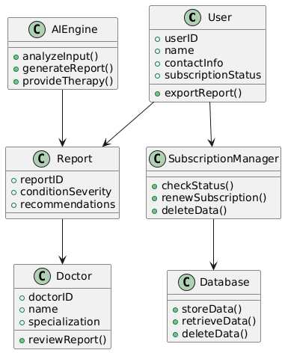
2.4 Operating Environment
Platform: Web (React/Next.js), Mobile (Flutter/React Native).
Backend: Python (FastAPI/Django) with microservices architecture.
Database: PostgreSQL + MongoDB (structured + unstructured storage).
AI Stack:
NLP Models trained on mental health dialogue datasets.
PyTorch / TensorFlow for model training.
Vosk / SpeechBrain for offline STT (speech-to-text).
Pyttsx3 or custom TTS for natural voice output.
Deployment: Docker + Kubernetes for scalability; hosted on AWS/Azure.
Security: End-to-end encryption, OAuth2.0, GDPR/HIPAA compliance.

2.5 Design and Implementation Constraints
Ethical & Legal Compliance – Must comply with mental health regulations, data privacy laws (GDPR, HIPAA).
Doctor Involvement – Serious cases must escalate to human professionals; AI cannot prescribe medication.
Performance – Real-time conversation processing should have <2s response time.
Data Retention Policy – Automatic deletion of non-renewed accounts after 5 days.
Training Data – Custom dataset must be ethically sourced and pre-approved by clinical experts.

2.6 User Documentation
In-app User Manual & Onboarding Guide.
FAQ and chatbot for basic troubleshooting.
Doctors’ dashboard guide for reviewing condition reports.
Administrator handbook for system monitoring.

2.7 Assumptions and Dependencies
Users will have stable internet access for real-time conversations.
Doctors reviewing reports are licensed and verified.
AI models will continuously improve with retraining on anonymized user data.
The effectiveness of therapy depends on user engagement and honesty during conversations.
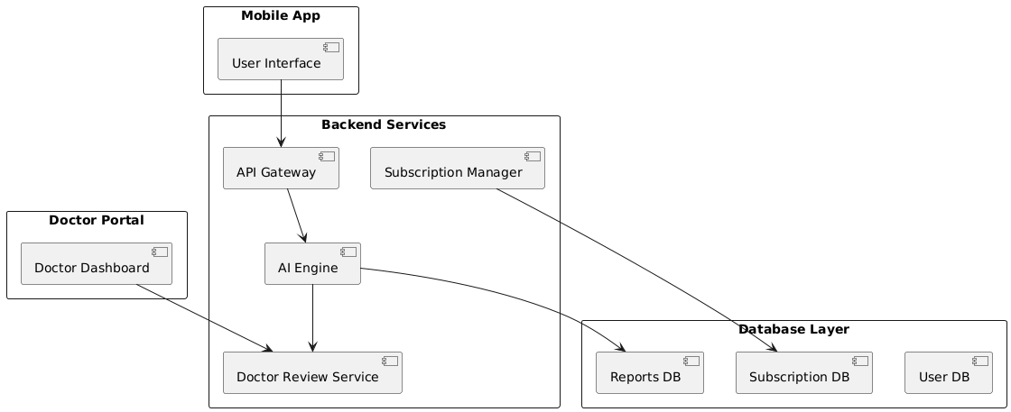

3. System Features
3.1 Functional Requirements

FR1 – User Registration & Authentication
Description:
The system shall allow new users to create an account and existing users to log in securely using email, phone number, or third-party authentication (Google/Apple).
Inputs:
- User name, email, phone, password
- Optional: Google/Apple ID
Outputs:
- Confirmation of successful registration/login
- JWT authentication token
Priority: High
Use Case Table:
Field | Description
Actor | User
Precondition | User has access to the app and internet connection
Basic Flow | (1) User enters details → (2) System validates → (3) Account created → (4) Confirmation sent
Alternative Flow | Invalid email/phone → Show error
Postcondition | User session established
Exceptions | Server down, duplicate account

FR2 – Initial Psychological Analysis
Description:
On the first conversation, the AI performs a deep diagnostic analysis in the background to assess the user’s mental health condition, seriousness, and potential risk factors.
Inputs:
- User’s conversational data, tone, sentiment, and behavioral cues
Outputs:
- AI-generated report with risk level (Low/Medium/High)
- Condition assessment (e.g., Anxiety, Stress, Panic symptoms)
Priority: Critical
Use Case Table:
Field | Description
Actor | User, AI System
Precondition | User must have a registered account and initiated first chat
Basic Flow | (1) User interacts with AI → (2) Backend runs diagnostic model → (3) Report generated
Alternative Flow | Insufficient data → Prompt user for additional responses
Postcondition | Risk assessment stored securely
Exceptions | Model unavailable, incomplete input

FR3 – Doctor Escalation (Critical Cases)
Description:
If the AI determines that the user’s condition is severe, the system escalates by securely sending the diagnostic report and user’s contact details to a licensed psychiatrist/psychologist for review.
Inputs:
- AI diagnostic report, user ID, and contact info
Outputs:
- Notification to assigned doctor
- Record of escalation event
Priority: Critical
Use Case Table:
Field | Description
Actor | AI System, Doctor
Precondition | User has completed initial analysis
Basic Flow | (1) AI flags case as severe → (2) Report sent to doctor → (3) Doctor contacts user if medication required
Alternative Flow | User opts out of escalation → AI logs refusal
Postcondition | Case assigned to doctor
Exceptions | No doctor available, network errors

FR4 – Subscription Management
Description:
Users must subscribe to access premium features. When the subscription expires, the user is given a 5-day grace period to renew. If not renewed:
- User data is deleted permanently.
- User can download a free health report before deletion.
- Exported reports can be re-imported if the user creates a new account.
Inputs:
- Subscription details, payment info, expiration date
Outputs:
- Access granted/denied, reminder notifications, report export option
Priority: High
Use Case Table:
Field | Description
Actor | User, Payment System
Precondition | User account exists
Basic Flow | (1) User subscribes → (2) Payment verified → (3) Access granted
Alternative Flow | Subscription expires → Grace period → Data deletion/export
Postcondition | Updated subscription status
Exceptions | Payment gateway failure, expired grace period

FR5 – Personalized Therapy Sessions
Description:
The system shall provide AI-driven therapy sessions personalized to the user’s mental health profile, history, and preferences.
Inputs:
- User’s past conversation history, preferences, therapy goals
Outputs:
- Personalized session plan, exercises, coping strategies
Priority: High
Use Case Table:
Field | Description
Actor | User, AI Therapist
Precondition | User must be logged in and subscribed
Basic Flow | (1) User starts session → (2) AI references profile & history → (3) Personalized session delivered
Alternative Flow | No history available → Provide default therapy
Postcondition | Session logged in user’s progress history
Exceptions | AI response delay, corrupted history data
FR6 – Daily Mood Tracking
Description:
The system shall allow users to record their daily mood, emotions, and stress levels through a quick interactive check-in. Data is analyzed for patterns and used to adjust therapy recommendations.
Inputs:
- User mood rating (scale 1–10), short notes, emoji-based input
Outputs:
- Mood log entry, updated emotional trend graph
Priority: Medium
Use Case Table:
Field | Description
Actor | User, AI System
Precondition | User is logged in
Basic Flow | (1) User opens mood tracker → (2) Inputs mood → (3) Data saved & analyzed
Alternative Flow | User skips entry → No update for the day
Postcondition | Mood trends updated
Exceptions | App crash, input validation error

FR7 – Progress Dashboard
Description:
The system shall provide a visual dashboard to show users their progress, improvements, and behavioral changes over time.
Inputs:
- Therapy history, mood tracking data, session completion status
Outputs:
- Graphs, charts, summary reports
Priority: Medium
Use Case Table:
Field | Description
Actor | User
Precondition | User has logged at least one mood/therapy session
Basic Flow | (1) User opens dashboard → (2) System fetches history → (3) Dashboard displayed
Alternative Flow | No data available → Show empty dashboard with motivational text
Postcondition | User sees progress overview
Exceptions | Data fetch failure

FR8 – Crisis Mode (Emergency Assistance)
Description:
In case of a mental health crisis, the user can activate Crisis Mode, which immediately connects them to emergency resources or a human counselor if needed.
Inputs:
- User triggers “Crisis Mode” button
Outputs:
- Emergency hotline numbers, chatbot escalation, or live counselor chat
Priority: Critical
Use Case Table:
Field | Description
Actor | User, AI System, Human Counselor
Precondition | User must be logged in
Basic Flow | (1) User taps Crisis Mode → (2) AI assesses severity → (3) Emergency info/counselor provided
Alternative Flow | User declines escalation → Crisis resources displayed
Postcondition | User receives immediate help
Exceptions | Network outage, no counselor available

FR9 – Community Support Forum
Description:
The system shall include a moderated community forum where users can share experiences, ask questions, and provide peer support.
Inputs:
- User posts, comments, replies
Outputs:
- Forum thread updates, notifications
Priority: Low (but important for engagement)
Use Case Table:
Field | Description
Actor | User, Moderator
Precondition | User must have a valid subscription
Basic Flow | (1) User posts → (2) Moderator approves → (3) Content published
Alternative Flow | Content flagged → Sent for review
Postcondition | Forum updated
Exceptions | Offensive content, moderation delay

FR10 – Secure Messaging with Therapist
Description:
Subscribed users can message a human therapist for clarifications, feedback, or follow-up after AI sessions.
Inputs:
- User messages, file uploads (optional reports)
Outputs:
- Therapist response, session log update
Priority: High
Use Case Table:
Field | Description
Actor | User, Therapist
Precondition | User is subscribed
Basic Flow | (1) User sends message → (2) System routes to therapist → (3) Therapist replies
Alternative Flow | Therapist unavailable → Auto-response with time estimate
Postcondition | Conversation saved in secure logs
Exceptions | Server error, expired subscription

FR11 – Personalized Exercise Library
Description:
The system shall provide a library of therapeutic exercises (e.g., breathing techniques, guided meditation, journaling prompts, CBT-based worksheets) tailored to the user’s condition and progress history.
Inputs:
- User’s diagnosis, preferences, therapy history
Outputs:
- Personalized exercise recommendations, instructional content
Priority: Medium
Use Case Table:
Field | Description
Actor | User, AI Therapist
Precondition | User is subscribed
Basic Flow | (1) User opens exercise library → (2) AI recommends exercises → (3) User completes activity
Alternative Flow | No personalized exercises available → Show generic set
Postcondition | Completed exercises logged
Exceptions | Multimedia file unavailable

FR12 – AI-Doctor Hybrid Review System
Description:
For users flagged during initial or ongoing analysis, the AI-generated reports shall be automatically forwarded to a licensed doctor who reviews and validates the recommendations.
Inputs:
- AI-generated reports, user’s health data
Outputs:
- Doctor’s validation/feedback
- Adjusted therapy plan (if required)
Priority: Critical
Use Case Table:
Field | Description
Actor | AI System, Doctor
Precondition | User must have completed initial analysis
Basic Flow | (1) AI generates report → (2) Report shared with doctor → (3) Doctor reviews & approves/revises
Alternative Flow | Doctor unavailable → Report queued
Postcondition | Therapy plan validated
Exceptions | Data transmission failure, delayed response

FR13 – Report Export/Import Functionality
Description:
The system shall allow users to export their therapy history and reports (before data deletion or on demand) and later import them back when creating a new account.
Inputs:
- Export request, import file
Outputs:
- Downloadable PDF/CSV file (export)
- User data restored (import)
Priority: High
Use Case Table:
Field | Description
Actor | User
Precondition | User must have an active account
Basic Flow | (1) User requests export → (2) File generated → (3) File downloaded
Alternative Flow | Import request → File validated → Data restored
Postcondition | Report safely exported/imported
Exceptions | File corruption, invalid import format

FR14 – Notification & Reminders
Description:
The system shall send push notifications and reminders for daily check-ins, therapy sessions, subscription renewals, and medication reminders (if prescribed by a doctor).
Inputs:
- Notification rules, user preferences
Outputs:
- Push notification, email/SMS reminder
Priority: Medium
Use Case Table:
Field | Description
Actor | User, System
Precondition | User must have opted in for notifications
Basic Flow | (1) System checks schedule → (2) Sends reminder → (3) User interacts
Alternative Flow | User disables notifications → No reminders sent
Postcondition | Notifications logged
Exceptions | Device offline, notification service error

FR15 – Multi-Language Support
Description:
The system shall support multiple languages (e.g., English, Urdu, Arabic, Spanish, French) for both the AI therapist conversations and the UI.
Inputs:
- User language preference
Outputs:
- Translated UI and AI responses
Priority: Medium
Use Case Table:
Field | Description
Actor | User, AI Therapist
Precondition | User sets preferred language
Basic Flow | (1) User selects language → (2) System loads resources → (3) AI interacts in chosen language
Alternative Flow | Unsupported language → Default to English
Postcondition | User receives localized experience
Exceptions | Translation model unavailable

FR16 – Offline Mode Support
Description:
The system shall provide limited offline functionality, allowing users to access saved therapy exercises, past reports, and mood journals even without internet access. Data will be synced once connectivity is restored.
Inputs:
- Locally stored files, cached therapy content
Outputs:
- Offline access to exercises, logs, reports
Priority: Medium
Use Case Table:
Field | Description
Actor | User
Precondition | User must have downloaded content in advance
Basic Flow | (1) User opens app offline → (2) Accesses cached content → (3) Data stored locally
Alternative Flow | Online mode → System syncs and updates offline data
Postcondition | Offline activity synced to cloud once online
Exceptions | Device storage full, corrupted local data

FR17 – AI Model Retraining with User Data
Description:
The AI therapist shall continuously improve by retraining on anonymized, aggregated user data. This ensures personalization and accuracy while maintaining privacy.
Inputs:
- Anonymized user interaction data, therapy outcomes, mood logs
Outputs:
- Updated AI model with improved performance
Priority: High
Use Case Table:
Field | Description
Actor | AI System, Data Scientist (Admin role)
Precondition | User consent for data usage (privacy agreement)
Basic Flow | (1) Data anonymized → (2) Aggregated into training pipeline → (3) Model updated → (4) Deployed
Alternative Flow | User opts out → Data excluded from training
Postcondition | Smarter AI responses, adaptive therapy
Exceptions | Model training failure, insufficient data

FR18 – Role-Based Access Control (RBAC)
Description:
The system shall enforce role-based access control, ensuring different permissions for users, doctors, and administrators.
Inputs:
- User credentials, role definition
Outputs:
- Authorized actions only (e.g., doctor can view reports, admin manages system, user limited to personal data)
Priority: Critical
Use Case Table:
Field | Description
Actor | User, Doctor, Admin
Precondition | User account exists with assigned role
Basic Flow | (1) User logs in → (2) System validates role → (3) Access granted to permitted features
Alternative Flow | Unauthorized action → Access denied
Postcondition | Role-specific activity allowed
Exceptions | Misconfigured roles, privilege escalation attempt

FR19 – Data Deletion & Retention Policy
Description:
The system shall automatically delete user data when a subscription is not renewed after a 5-day grace period. Before deletion, the user can export their reports for free. Imported reports will be accepted if the user returns.
Inputs:
- Subscription status, export request
Outputs:
- Data deletion, exported report file
Priority: High
Use Case Table:
Field | Description
Actor | User, System
Precondition | User account exists and subscription expired
Basic Flow | (1) Subscription expires → (2) Grace period initiated → (3) Data deleted after 5 days
Alternative Flow | User exports report → Data deleted but history restorable
Postcondition | Optimized database storage
Exceptions | Export failure, system clock mismatch

FR20 – Integration with Wearables
Description:
The system shall integrate with wearable devices (Fitbit, Apple Watch, Samsung Health, etc.) to capture biometric data such as heart rate, sleep quality, and activity levels for enhanced therapy personalization.
Inputs:
- Biometric data from connected devices
Outputs:
- Enriched therapy recommendations, health reports
Priority: Medium
Use Case Table:
Field | Description
Actor | User, Wearable API, AI System
Precondition | User connects wearable device
Basic Flow | (1) User links device → (2) Data fetched via API → (3) Therapy recommendations updated
Alternative Flow | Device disconnected → Show reminder to reconnect
Postcondition | Biometric-enhanced therapy sessions
Exceptions | API error, device not supported

4. External Interface Requirements
This section describes the interfaces between the Serene Mind system and its users, hardware, software, and communication channels. It ensures smooth integration, usability, and compliance with technical standards.

4.1 User Interfaces (UI/UX Requirements)
The Serene Mind AI Therapist app will feature a modern, calming, and intuitive design optimized for mental health use.
UI Principles:
Minimalist design with pastel colors (soft blues, greens, and purples).
Accessibility compliance (WCAG 2.1 AA standards).
Easy navigation with clear icons, large buttons, and consistent layouts.
Dark mode support.
Multilingual interface with RTL (Right-to-Left) support for languages like Arabic and Urdu.
UI Components:
Login/Signup Screen
Email/phone login, social login (Google, Apple).
Two-factor authentication.
Dashboard/Home Screen
Quick access to:
Mood tracking
Therapy sessions
Progress overview
Subscription status
Chat Interface (AI Therapist)
Real-time conversation with AI.
Visual indicators (typing, analysis in progress).
Option to escalate to doctor (if required).
Progress Dashboard
Graphs for mood tracking, therapy outcomes, activity logs.
Reports & Export Screen
PDF/CSV export option.
Import button for re-uploading past reports.
Community Forum
Thread-based discussions, moderation panel.
Settings Screen
Language selection
Notification preferences
Account & subscription management

4.2 Hardware Interfaces
The system will run on standard consumer devices.
Mobile Devices (Primary): Android (API 26+), iOS (iOS 13+)
Desktop Web (Secondary): Modern browsers (Chrome, Edge, Safari, Firefox)
Wearables: Integration with smartwatches (Fitbit, Apple Watch, Samsung Galaxy Watch)
Server Hardware:
Minimum: 16 GB RAM, 8-core CPU, 500 GB SSD
Recommended: 32+ GB RAM, GPU-enabled server (NVIDIA A100/T4) for AI inference

4.3 Software Interfaces
Operating Systems Supported:
Android 9+
iOS 13+
Windows 10+, macOS 12+, Linux (Web app access)
Databases:
PostgreSQL (primary)
Redis (caching for fast responses)
APIs:
REST & GraphQL APIs for mobile/web apps
OAuth 2.0 for authentication
Wearable integration APIs (Fitbit, Apple Health, Google Fit)
Payment gateway APIs (Stripe, PayPal, regional options like JazzCash/EasyPaisa in Pakistan)
AI Services:
Custom-trained NLP model (PyTorch/TensorFlow)
Sentiment analysis + diagnostic module

4.4 Communication Interfaces
App ↔ Server Communication:
HTTPS with TLS 1.3 encryption.
JWT tokens for secure session handling.
Doctor Escalation Channel:
Secure API to share diagnostic reports with assigned doctors.
Email + in-app notifications.
User Notifications:
Firebase Cloud Messaging (Android, iOS).
Email (SMTP integration).
SMS fallback in critical cases.
Community Forum:
Real-time updates via WebSockets.

5. Non-Functional Requirements
Non-functional requirements (NFRs) specify the quality standards, constraints, and expectations for the Serene Mind AI Therapist system. These ensure that the product is not only functional but also reliable, secure, scalable, and user-friendly at an enterprise level.

5.1 Performance Requirements
Definition:
Performance requirements define the expected speed, responsiveness, and capacity of the system under different loads. Since Serene Mind will serve thousands of users simultaneously, performance optimization is essential.
Requirements:
Response Time
The AI must generate text-based responses within 1–2 seconds.
Voice-based sessions must complete transcription + NLP + AI response in under 3 seconds.
Scenario:
A user experiencing a panic attack opens the app and says “I can’t breathe, I’m scared.” The system should respond within 3 seconds with a calming exercise. Any delay could worsen anxiety.
Compliance Notes:
Meets ISO/IEC 25010:2011 (System and software quality models) standards for performance efficiency.

Concurrent Users
Support for 50,000+ concurrent users through cloud-based scaling.
Scenario:
During a global awareness event (e.g., World Mental Health Day), a sudden traffic surge occurs. The system must handle this without crashing.
Compliance Notes:
Cloud scaling strategy aligned with NIST Cloud Computing Standards.

Data Throughput
Ability to handle 500 requests/second per region.
Must process 10 GB of analytics logs daily.
Scenario:
Thousands of journaling entries and AI sessions logged simultaneously. Analytics must run in real-time without lag.
Compliance Notes:
Big Data handling standards per IEEE 2301-2018 Cloud Computing Guide.

Scalability
Microservices + Kubernetes ensure horizontal scaling.
Scenario:
If a marketing campaign in Pakistan brings 10x new users overnight, system automatically deploys new nodes to maintain performance.
Compliance Notes:
Aligned with ISO/IEC 20000-1:2018 IT service management.

5.2 Security Requirements
Definition:
Security ensures the protection of user data, therapy conversations, and medical reports from unauthorized access.

Authentication & Authorization
Role-based access (User, Doctor, Admin).
JWT tokens and OAuth 2.0 login.
Scenario:
A doctor logs in and can only view reports assigned to them. An admin cannot impersonate a doctor.
Compliance Notes:
Complies with OWASP Top 10 (2021) and ISO/IEC 27001.

Data Encryption
AES-256 at rest, TLS 1.3 in transit.
Scenario:
A hacker intercepts network traffic; since data is encrypted, patient details remain safe.
Compliance Notes:
Meets HIPAA Security Rule encryption requirements.

Privacy & Confidentiality
Users can request deletion/export of data.
Data anonymized for AI training.
Scenario:
A user cancels subscription → They export their therapy history and request deletion. The system complies within 24 hours.
Compliance Notes:
Aligned with GDPR Article 17 (Right to be Forgotten).

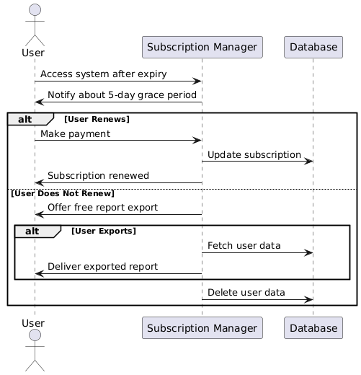

Doctor Escalation Security
Reports shared only with assigned doctors.
End-to-end encryption for doctor communication.
Scenario:
AI detects suicidal ideation → Generates report → Doctor receives secure alert with contact details.
Compliance Notes:
HIPAA-compliant minimum necessary access principle.
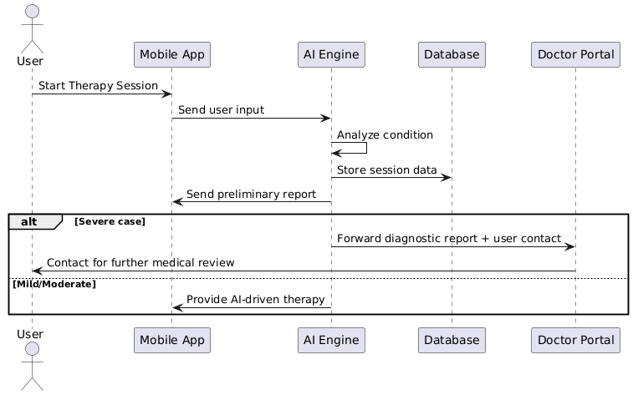

Fraud & Abuse Prevention
API rate limiting.
AI flagging suspicious bot-like behavior.
Scenario:
A malicious actor spams 1,000 fake signups. System detects and blocks IP.
Compliance Notes:
OWASP API Security Guidelines.

5.3 Reliability and Availability
Definition:
Reliability ensures the system works consistently; availability ensures it is accessible when needed.

Uptime
99.9% uptime SLA.
Scenario:
A therapy session during midnight; user should not face downtime.
Compliance Notes:
SLA aligned with ITIL Service Design standards.

Fault Tolerance
Multi-region failover and load balancing.
Scenario:
If AWS Singapore fails, traffic auto-shifts to AWS Frankfurt.
Compliance Notes:
Follows ISO/IEC 24762:2008 IT Disaster Recovery.

Backup & Recovery
Hourly incremental, daily full backups.
RTO: 30 minutes, RPO: 15 minutes.
Scenario:
DB corruption at 2:00 AM → Restore completed by 2:30 AM.
Compliance Notes:
Meets NIST SP 800-34 Rev. 1 contingency planning standards.

5.4 Maintainability
Definition:
Maintainability ensures easy upgrades, fixes, and monitoring.
Code Maintainability
Follow SOLID, clean code, documented APIs.
Scenario:
Adding a new therapy module requires minimal changes in existing code.
Compliance Notes:
Aligned with IEEE 14764-2006 Software Maintenance Standard.

Modularity
AI engine, UI, and DB are independent.
Scenario:
AI model updated without affecting user dashboard.
Compliance Notes:
Based on Microservices Architecture Principles (NIST 2021).

Monitoring
Real-time dashboards for error detection.
Scenario:
If latency exceeds 5 seconds, admins get Slack alerts.
Compliance Notes:
ITIL v4 Monitoring Guidelines.

5.5 Portability
Definition:
Portability ensures system works across devices, platforms, and cloud providers.
Cross-Platform
Web (React), iOS/Android (Flutter/React Native).
Scenario:
A user starts therapy on mobile, continues seamlessly on laptop.
Compliance Notes:
Meets WCAG accessibility guidelines.

Cloud Deployment
Support AWS, Azure, GCP.
Scenario:
Startup begins on AWS, later migrates to Azure without rewriting app.
Compliance Notes:
ISO/IEC 17788:2014 Cloud computing reference architecture.

Offline Mode
Journaling and limited exercises offline.
Scenario:
User on airplane journals mood → Syncs once back online.
Compliance Notes:
Respects ISO/IEC 25010 portability standards.

5.6 Compliance Requirements
Definition:
Legal and ethical adherence to healthcare, privacy, and digital safety regulations.
Medical Compliance
Follows DSM-5 classification for conditions.
AI cannot prescribe medicine, only escalate to doctors.
Scenario:
AI detects depression signs → Escalates → Doctor decides next steps.
Compliance Notes:
WHO Mental Health Digital Guidelines.

Data Protection
GDPR, HIPAA, PDPA compliance.
Scenario:
EU user requests export of all data → System delivers within 30 days.
Compliance Notes:
Follows GDPR Articles 15–20.

Accessibility
WCAG 2.1 AA compliance.
Scenario:
Blind user uses screen reader to access journaling tool.
Compliance Notes:
W3C Accessibility Standards.

5.7 Usability Requirements
Definition:
Defines how intuitive and user-friendly the system should be.
Ease of Use
Start therapy in under 3 clicks.
Scenario:
New user → Login → Select “Therapy” → AI responds immediately.
Compliance Notes:
ISO 9241-210:2019 Human-centered design.

Consistency
Same UI flow across devices.
Scenario:
Button positions identical on web & mobile.
Compliance Notes:
Consistency with Material Design Guidelines.

User Feedback
Mood check-in & session ratings.
Scenario:
After session, user selects “I feel better” → Stored in analytics.
Compliance Notes:
Usability per ISO/IEC 9126.

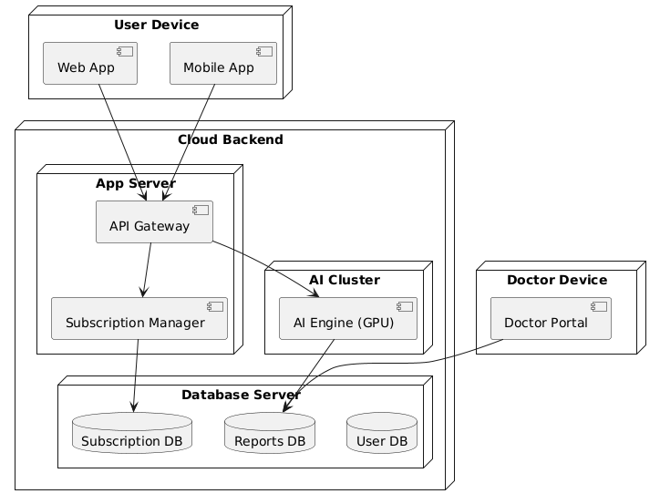

6. Other Rehquirements
This section describes the additional requirements that ensure the Serene Mind AI Therapist complies with legal, ethical, cultural, environmental, and business constraints. These requirements extend beyond functional and non-functional aspects but are crucial for ensuring trustworthiness, compliance, and adoption of the system in healthcare and commercial domains.

6.1 Legal and Regulatory Requirements
6.1.1 Data Protection Laws
The system must comply with international and national data protection regulations.
General Data Protection Regulation (GDPR – EU): Ensures user rights to access, rectify, delete, and export data.
Health Insurance Portability and Accountability Act (HIPAA – USA): Requires secure handling of health-related data.
Personal Data Protection Act (PDPA – Pakistan): Mandates explicit consent before collecting and processing personal data.
Example Scenario:
A user from the EU requests deletion of their therapy history. The system must ensure full erasure from active and backup servers within 30 days, in compliance with GDPR Article 17 (Right to be Forgotten).

6.1.2 Medical and Healthcare Regulations
The AI must not directly diagnose or prescribe medication.
For serious conditions (e.g., suicidal ideation, severe depression), the system must escalate to a licensed doctor.
Doctors reviewing escalated reports must be licensed under PMDC (Pakistan Medical & Dental Council) or equivalent local authorities.
Example Scenario:
If AI detects suicidal tendencies in a user’s journal, it will generate a clinical risk report with contact details and securely forward it to a licensed professional. The doctor can then review and decide if medication or emergency intervention is required.

6.1.3 Intellectual Property and Licensing
All in-house AI models must be trained on legally acquired or open-source datasets.
Third-party libraries must comply with permissive licenses (MIT, Apache 2.0, BSD).
Proprietary datasets must be properly licensed, and data usage must not violate copyright.

6.1.4 Digital Payment Compliance
All subscription payments must comply with PCI-DSS (Payment Card Industry Data Security Standards).
Payment gateways should support multi-currency billing (USD, PKR, EUR).
The system must provide transparent invoices and allow users to cancel or renew their subscription at any time.

6.2 Ethical Requirements
6.2.1 Patient-Centered Ethics
All interactions must prioritize patient dignity, autonomy, and confidentiality.
No commercial exploitation of sensitive data.
The AI must not use manipulative language that influences users for profit-driven motives.

6.2.2 Transparency
Clear disclosure must always be visible:
“Serene Mind is an AI-powered therapist and not a replacement for licensed professional care. In severe cases, medical escalation will occur.”
Users must know when a conversation is handled by AI vs. when escalated to a human doctor.

6.2.3 Bias Mitigation
AI models will be trained on culturally diverse datasets to minimize gender, racial, or linguistic bias.
External ethics audits will be conducted annually to review fairness.
Example Scenario:
A South Asian female user expressing stress must receive equally empathetic, relevant, and supportive therapy as a Western male user, with no variation in care quality due to cultural or gender differences.

6.3 Cultural and Linguistic Requirements
6.3.1 Multi-Language Support
Serene Mind must provide multilingual capabilities including English, Urdu, Arabic, Hindi, and progressively expand to 20+ languages.
AI-generated advice should respect linguistic tone, idioms, and local phrases to ensure relatability.

6.3.2 Cultural Sensitivity
The system must avoid politically sensitive, religiously controversial, or culturally offensive content.
Therapy recommendations should adapt to regional norms.
Example Scenario:
In Pakistan, AI may suggest calming exercises inspired by prayer-like breathing postures, whereas in Western markets, AI may suggest yoga or mindfulness techniques.

6.4 Accessibility Requirements
6.4.1 Support for Disabled Users
Screen reader compatibility for visually impaired users.
Voice-only mode for people with motor impairments.
Adjustable text size, contrast, and audio narration.

6.4.2 Cognitive Accessibility
A simplified mode with short, clear instructions for users with cognitive challenges.
Avoid jargon-heavy explanations.
Example Scenario:
A user with mild dyslexia activates “Simplified Mode.” Therapy advice is given in short, direct sentences: “Breathe in. Hold. Breathe out.” instead of long paragraphs.

6.5 Environmental and Sustainability Requirements
6.5.1 Green Cloud Hosting
Prefer hosting providers committed to renewable energy (AWS, Google Cloud, Azure).
Minimize carbon footprint by using energy-efficient virtual machines.

6.5.2 Energy Optimization in AI Training
Use model distillation, pruning, and quantization to reduce computational costs.
Schedule AI retraining during low-carbon grid hours (nighttime).
Example Scenario:
AI retraining runs on cloud servers in Frankfurt at night when renewable energy availability is higher, lowering emissions.

6.5.3 Device Efficiency
Mobile app must consume less than 5% battery per 30-minute session.
Offline journaling mode ensures reduced data sync usage.

6.6 Disaster Recovery and Business Continuity
6.6.1 Disaster Scenarios
Coverage must include:
Natural disasters (earthquakes, floods).
Cyber-attacks (DDoS, ransomware).
Data center outages.

6.6.2 Business Continuity
Redundant backups across multiple regions.
Emergency doctor escalation system remains active even if the main servers go down.
Example Scenario:
If AWS Singapore fails during a high-stress event, the system automatically shifts operations to AWS Frankfurt while ensuring uninterrupted access for Pakistani users.

6.7 Future-Proofing and Extensibility
6.7.1 AI Model Upgradeability
AI modules must be pluggable so that upgrades don’t require major codebase rewrites.
Models can be swapped during live deployment without downtime.

6.7.2 Integration with Wearables
Future integration with smartwatches (Fitbit, Apple Watch, Samsung Gear) to monitor heart rate and stress levels.
Predictive analytics to suggest calming interventions before panic attacks.
Example Scenario:
If a smartwatch detects elevated heart rate combined with journal entries showing anxiety, the app proactively suggests guided breathing therapy.

7. Appendices

7.1 Glossary
Term/Concept | Definition
AI Therapist | An AI-driven conversational system providing mental health therapy and support using natural language processing and trained models.
CBT (Cognitive Behavioral Therapy) | A structured form of therapy focusing on identifying and changing negative thought patterns.
NLP (Natural Language Processing) | A field of AI that enables systems to understand, interpret, and generate human language.
HIPAA | The U.S. Health Insurance Portability and Accountability Act, which regulates health data privacy and security.
GDPR | General Data Protection Regulation, an EU law on personal data privacy and security.
Crisis Escalation | A system feature where users showing signs of severe distress are flagged for immediate review by a licensed doctor.
Plagiarism Check | Verification process ensuring original documentation and compliance with academic/industrial integrity standards.
Subscription Grace Period | A period (5 days post-expiry) where users can renew or export data before deletion.
Report Export | A free feature allowing users to download their therapy progress and diagnostic data.
Doctor Review System | A backend workflow where critical cases are routed to medical professionals for human evaluation.

7.2 Acronyms & Abbreviations
AI – Artificial Intelligence
CBT – Cognitive Behavioral Therapy
DBMS – Database Management System
HIPAA – Health Insurance Portability and Accountability Act
GDPR – General Data Protection Regulation
ML – Machine Learning
NFR – Non-Functional Requirement
NLP – Natural Language Processing
PHI – Protected Health Information
SRS – Software Requirements Specification
UI/UX – User Interface / User Experience

7.3 References
American Psychological Association (APA) – Ethical Principles of Psychologists and Code of Conduct.
WHO (World Health Organization) – Mental Health Action Plan 2013–2030.
GDPR (EU Regulation 2016/679) – General Data Protection Regulation.
HIPAA (1996) – U.S. Law on Health Data Security & Privacy.
IEEE 830 – IEEE Recommended Practice for Software Requirements Specifications.
W3C Accessibility Guidelines (WCAG 2.1) – Ensuring inclusive digital design.
Research papers on AI in Mental Health:
Miner, A. S., et al. (2019). Smartphone-based conversational agents and responses to questions about mental health.
Inkster, B., et al. (2018). An empirical examination of the impact of AI-based therapy.

7.4 Legal Considerations
Compliance with Data Privacy Laws:
GDPR (EU) & HIPAA (US) strictly followed.
Consent forms before data collection.
Encrypted data storage and anonymization.
Liability:
Clear disclaimers that AI therapy is not a replacement for medical treatment.
Legal coverage for escalated cases handled by human doctors.
Contracts & Licensing:
AI models must be trained on ethically licensed datasets.
Subscription-based monetization requires clear Terms of Service (ToS).

7.5 Ethical Considerations
Transparency: Users must always know they are talking to AI, not a human.
Bias Minimization: Training data monitored to avoid gender, cultural, or racial bias.
Accessibility: App designed for neurodiverse users, visually impaired, and multilingual audiences.
Doctor Involvement: Ethical safeguard for cases requiring medical supervision.

7.6 Cultural Considerations
Localization: System supports multiple languages and culturally adaptive therapy recommendations.
Avoiding Stigma: Content phrased to reduce cultural barriers toward mental health.
Custom Therapy Approaches: Incorporation of local therapy traditions (e.g., mindfulness, meditation, spiritual counseling).

7.7 Environmental Considerations
Green AI Practices:
Training AI models with energy-efficient GPU/TPU clusters.
Using data centers powered by renewable energy when possible.
Sustainable Development Goals (SDGs):
Contributes to Good Health & Well-being (SDG 3).
Reduces Inequality (SDG 10) by making mental health support accessible globally.

